http://howtodoright.com/squirrels/

Important facts:

1. There are over 265 species of squirrel worldwide. The smallest is the African pygmy squirrel which is tiny at around 10 cm long, whereas the largest, the Indian giant squirrel is a massive three feet long.
2. When a squirrel is scared and feels that it is in danger, it will at first remain motionless. If it is on the ground, it will run to a nearby tree and climb to safety, and if it is already in a tree it will circle the trunk and press up against the bark tightly with its body.
3. Squirrels are very trusting animals, and are of the very few wild animal species which will eat out of a person’s hand.
4. In colder regions such as the UK, squirrels plan ahead in order to survive the challenging winter months. They store nuts and seeds at various locations and return to them throughout the winter to maintain their energy levels when food is scarce.
5. Squirrels tend to run in erratic paths. This is intended to deceive potential predators as to its chosen direction so that it may escape.
6. Squirrels are extremely intelligent creatures. They are known to put on elaborate bogus food burying displays to deceive onlookers. The fake burials are to trick potential thieves, such as other squirrels or birds, into thinking that they have stored their food stock there. Any observers planning on taking the stash will then focus on the bogus burial site, allowing the squirrel to bury the real stash elsewhere safely.
7. Tree-dwelling squirrels such as the grey squirrel build dreys (similar to bird’s nests) made of twigs high in trees. They are about the size of a football and are lined with grass, bark, moss and feathers for added comfort and insulation.
8. Squirrels communicate with each other through various vocalisations and scent marking. They also use their tails as a signalling device, twitching it when uneasy to alert other squirrels of potential danger
9. There are 44 species of ‘flying squirrel’. Rather than actually flying, these species glide using a membrane which stretches from their wrists to their ankles. It allows squirrels to glide naturally like humans do with the aid of a parachute
10. The squirrel is the Native American symbol for preparation, trust and thriftiness.

Common in:

* North America
* Europe

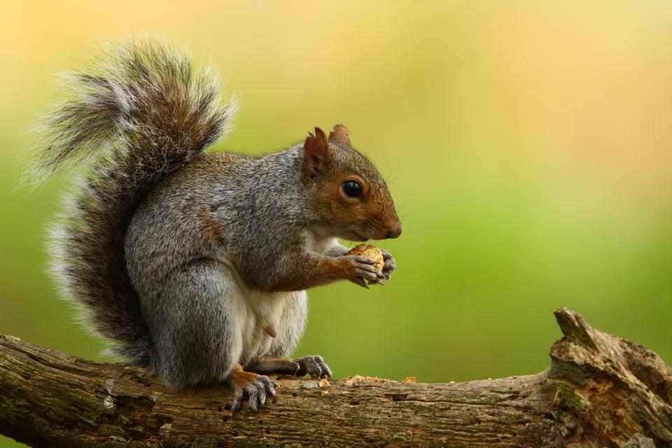

Species table:

|  |  |
| --- | --- |
| Species | זן |
| Western gray squirrel | סנאי מערבי אפור |
| Eastern gray squirrel | סנאי מזרחי אפור |
| Eastern fox squirrel | סנאי אדום מזרחי |
| Douglas squirrel | סנאי דאגלס |